This is an instruction on how to add multiple users and assign role to the users in Jenkins.

Tools needed: -

* Jenkins
* PostMan
* CSV file

PostMan- It is a popular API client. It is an interactive and automatic tool for verifying the APIs

To download Postman: <https://www.postman.com/downloads/>

**How to add Multiple users?**

Step1:

* If you are using the version 2.222.1, make sure to disable CSRF protection.
* Go to Manage Jenkins -> Script Console -> hudson.security.csrf.GlobalCrumbIssuerConfiguration.DISABLE_CSRF_PROTECTION = true

This will disable CSRF protection as well as the configuration UI for it

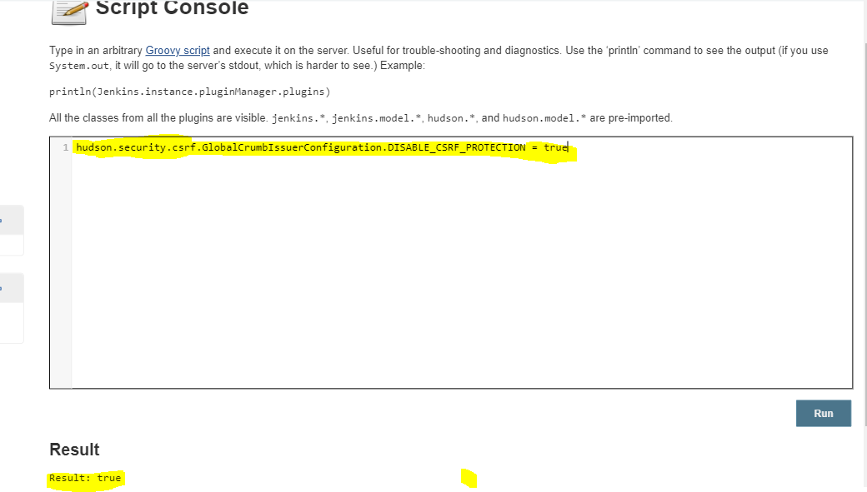

Step2: Run the java code JenkinsClientMultipleUser.java

It will show a small user prompt that require Jenkins user name and password. Then it has two choices and choose the first option to add multiple users from the csv file. Make sure the csv file named as students.csv

Response code: 302 is adding new users

Response code: 200 when the user already exist

This is how it looks like.

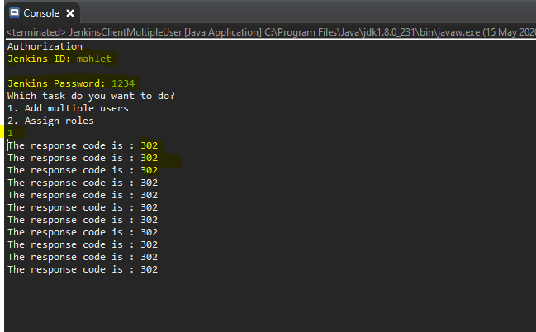

After this refresh your Jenkins, and you should be able to see the new users.

**How to add role to users?**

Step 1: Make sure as the CSRF protection is disable as shown above

Step 2: Run the JenkinsClientMultipleUser.java and choose the second option to assign roles. This will return json string value that shows the users with available roles.

true: assign the role to the user

false: user doesn’t have the role

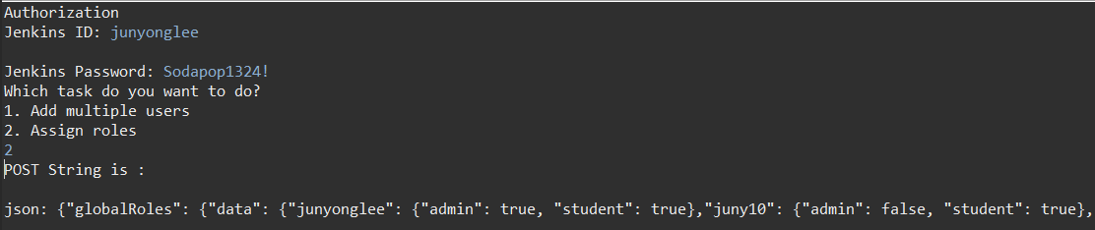

Step3: Go to postman

Step 4: Set the request **POST**,

Step 5: give URL <http://localhost:8080/role-strategy/assignSubmit>

Step 6: In the ‘Authorization’ tab, enter your Jenkins Id and password and change the TYPE to *Basic Auth* as shown below

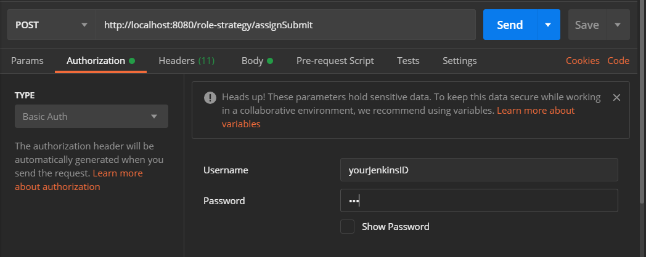

Step 7: In the Body section, choose x-www-form-urlencoded and paste the json string value we obtain early from the java code

(You can click ‘Bulk Edit’ button at the right side of the screen to add the json string as below)

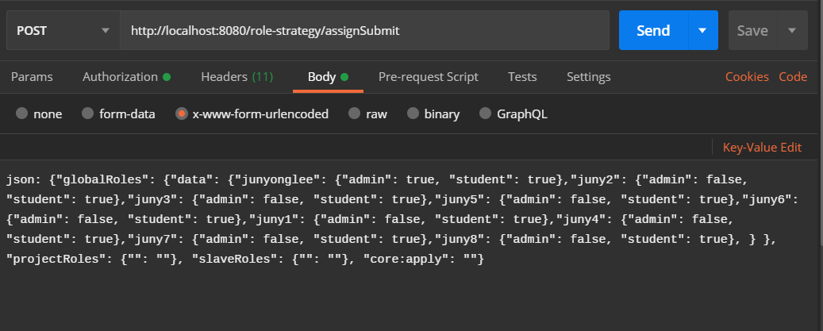

In Jenkin page, you can see the result. The program assumes that you already have role ‘student’. So make sure you have ‘student’ role already before you run this part.

